## 8.Generate Report

You will be given a **web page**, containing a **table** and **output area**.

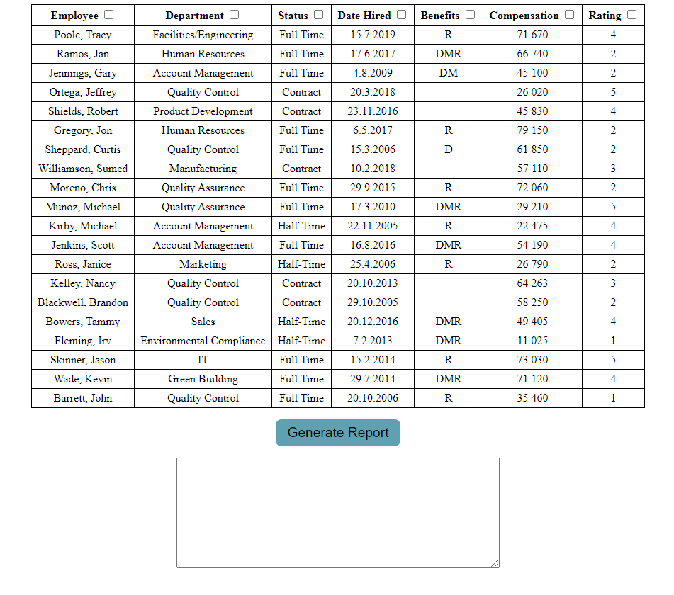

When the **"Generate Report"** button is **pressed**:

* You must generate a **JSON** **report** from the data inside the table, by **only taking the columns**, which are **selected**.

Each table header has a **checkbox**. If the checkbox is **checked**, then the data from this column must be included in the **report**. **Unchecked** columns must be **omitted**.

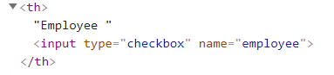

For **every row** (excluding the header):

* Create an **object** with **properties for each** of its columns.
* The name of each property is the name attribute of the column’s header, and the value is the text content of the cell.
* Store the result in an array and output it as a JSON string display it inside the **<textarea>** with **id "output"**. See the example for details.

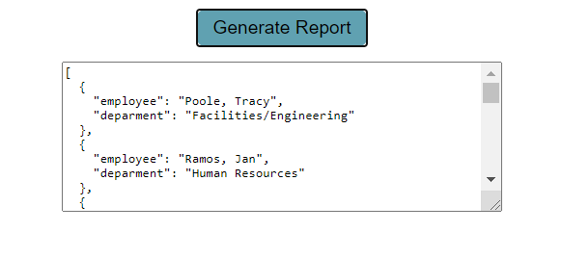

### Input/Output

There will be input, your program must execute based on the page content. The output must be a **JSON string**, displayed in the **<textarea>** with **id "output"**.

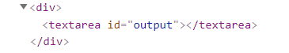

### Example

